Job Description Form
Registered Nurse – Paediatric Primary Care
Vision Statement
Aboriginal people in Kununurra and the North-East Kimberley are supported to live

prosperous lives that are strong, healthy, and culturally safe.

The Purpose that defines us
We bring clinical, cultural, and community expertise to deliver accessible and
holistic health and wellbeing care for people in the North-East Kimberley.

Aboriginal Community-led
We are connected and accountable to the communities we serve. We are governed by Aboriginal community leaders. We deliver services in culturally safe ways, bringing the best of medical and cultural expertise to achieve positive health outcomes. Working with and responding to Aboriginal communities is central to what we do.

Organisational Values
The Ord Valley Aboriginal Health Service has been providing critical health and support services to local Aboriginal people since 1984. Our ambition is to deliver socially, culturally, and financially accessible health care that supports communities in the North-East Kimberley to be strong, healthy and safe. The organisation operates on the foundational pillars of Aboriginal leadership, self-determination and cultural diversity that underpin and shape the way the organisation conducts its business.

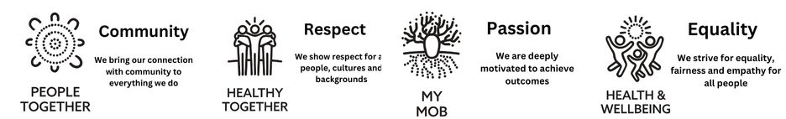

Position Title | Registered Nurse – Paediatric Primary Care
Work Group | Clinic
Work Unit | Clinic
Reports To | Derek Donohue, Practice Nurse Manager
Direct Reports | 0
Award / Agreement | Nurses Award 2020
Award Classification | RN Grade 2 ($90,396.07 - $95,000.00)
Approved by CEO | 11.08.2023

Team Structure

Position Purpose

This role is responsible for providing primary health care services to clients at the clinic and in the community focusing on from 0 to 4 years of age. This includes the assessment and management of acute presentations of children to the clinic following the Kimberley Sick Child Protocols. The role coordinates the visiting Paediatrician’s lists, supports the clinic and arranges follow ups, where needed; and works closely with partnering agencies and services to ensure the focus of care is on the needs of Aboriginal clients within the context of their cultural identify and social circumstances.

Aboriginal and/or Torres Strait Islander persons are strongly encouraged to apply.
Strategic Alignment
The organisation’s Strategic Plan 2023- 2026 has four (4) overarching strategic goals, with each goal having specific outcomes.

The role of Registered Nurse – Paediatric Primary Care is aligned with all four Strategic Goals.

Key Stakeholder Relationships
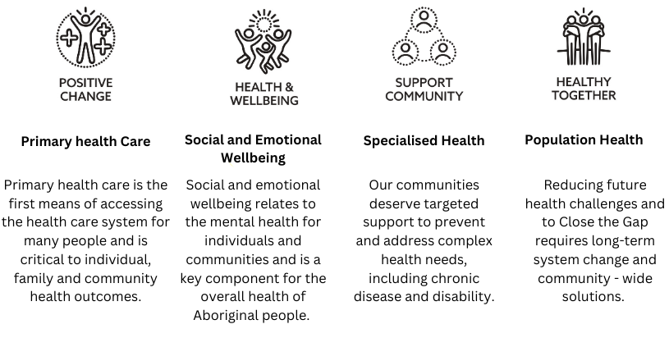

External
- Aboriginal Community Controlled Health Services across the Kimberley region and Western Australia, other not-for-profit services, and businesses as relevant to the role
- Liaises with a variety of government agencies, stakeholder representative groups and community groups.
Internal
- Maintains close working relationships with other officers, team members and employees of Ord Valley Aboriginal Health Services.
- Works in collaboration with the Senior Management Team and in consultation with the Board of Directors.

Responsibilities of this Position

- Be accountable for the safe, efficient, and effective use of resources, including assisting with forwards planning for OVAHS.
- Participant in developing and implementing programs to enhance the health and wellbeing of children 0 to 15 years of age.
- Perform clinical duties, as part of the maternal and child health team, in all areas of the health service.
- Perform Medicare benefits schedule items for health checks (715), GP management plans (721,723) for children 0 to15 years of age. DOH Enhanced Aboriginal Child Health Checks for children 0 – 5 years.
- Provide education to clients in disease prevention, management of health conditions and treatment requirements.
- Work within your level of professional competency and seek advice and clinical guidance from senior clinical staff as required.
- Be prepared to share your clinical knowledge and expertise with other staff members.
- Follow OVAHS clinical policies and procedures.
- Participate in the development, presentation, evaluation and written reports of health programs and services.
- Participate in ongoing training by OVAHS and other agencies as required.
- Promote OVAHS service areas: Sexual Health, Maternal and Child Health, Women’s Health and the Social Support Unit services to clients and initiate referrals.
- Provide support and assistance to visiting Specialists, Allied Health Staff, and other health agencies.
- Work with external agencies to deliver best practice client care including Community Health, Mental Health, Department of Child Protection, Environmental Health, Home and Community Care, Home Care Nurse, and Hospital Services.
- Assist in client follow up and liaise with other agencies when necessary.
- Liaise with the Specialist Clerk to organise referrals to allied health clinics.
- Maintain a clean and hygienic environment in the clinic and participate in maintaining, restocking, calibrating, and replacing clinic stores and equipment.
- Work within the parameters of OVAHS OHS policies and procedures including Infection Control, Emergency Evacuation, Outreach and Remote Visits and reporting of Incidents, Accident and Near Misses (and Hazards)
____________________________________________________________________________________________________________
General Duties
- Follow the policies and procedures documented in the OVAHS Quality Management System (QMS) and practice in accordance within guidelines, standards, code of ethics/conduct and statutory requirements applicable to your role as an OVAHS employee.
- Behave in a manner appropriate and respectful to local culture including gender sensitivities during work time and while representing OVAHS in the community.
- Participate in professional development activities and supervision as required.
- Undertake specific after-hours work, including attendance at training as required.
- Attend internal and external meetings as requested.
- Undertake relevant and appropriate multi-functional duties.
- Report relevant clinical cases or issues to line manager which may have possible legal implications.
- At all times maintain a professional relationship with patients, other employees, and visitors to OVAHS.
- Promote positive public relations with patients, peers, government and non-government agencies and services to achieve equitable outcomes for patients.
- Perform other duties as directed by Senior Management.

Governance: Organisational Safety and Quality Requirements
- Participates in the maintenance of a safe work environment and recognises acts on risks.
- Participates in an annual performance development review.
- Supports the delivery of safe and effective patient care and the consumers’ experience including participation in continuous quality improvement activities in accordance with the requirements of the ISO 2015: 9001 and RACGP Accreditation and the delegations on the Quality Management System (QMS).
- Completes mandatory training (including safety and quality training) as relevant to role.
- Performs duties in accordance with credentialing, Government Standards of Health Care Provision, OVAHS Organisational and, Area / Program specific policies and procedures.
- Abides by the OVAHS Code of Conduct, National Health Practitioners Boards’ Codes and Guidelines, Occupational Safety and Health Legislation, Disability Services Act, Road Traffic Act and the Equal Opportunity Act.
____________________________________________________________________________________________________________
Governance: Cultural Safety and Quality Requirements
- Participate in cultural safety and competence training and staff development.
- Respect and abide by the direction of Aboriginal employees in matters related to cultural safety.
- Support language access and communication.
- Forward grievances and complaints to allocated Senior Aboriginal employee.
- Support the input and participation, from the Aboriginal community and patients, in the development of continuous quality improvement.
____________________________________________________________________________________________________________
Administrative Duties
- Maintain statistics, administrative records, and client documents as per OVAHS policies and procedures.
- Produce report for OVAHS and funding bodies as required.
- Ensure maintenance of equipment and resources, including clinical equipment, IT equipment, vehicles, and phones.
- Perform office duties including, but not limited to, photocopying, faxing, laminating, processing paperwork and produces minutes for meetings as requested.

Quality Management System
- Actively participate in the organisation’s QMS (LOGIQC).
- Identify and participate in continuous quality improvement activities and apply quality improvement principles to all duties performed.
- Demonstrate leadership and commitment to promote continuous quality improvement initiatives, give assurance that the quality objectives are measured and ensure the QMS achieves intended results by engaging and supporting employees to contribute to the effectiveness of the QMS.
General
- Demonstrate a strong commitment to uphold and contribute to the organisation’s mission, objectives, and values.
- Support and promote teamwork through open communication, collaboration and contribute to a positive workplace culture.
- Attend and participate in professional development activities including workshops and training as required.
- Attend and participate in Employee Development Days.
- Participate and comply with all Work Health and Safety responsibilities as per the Work Health and Safety Act 2020 (WA).
- Identify and assist to reduce Work Health and Safety hazards and risks.
- Follow the reasonable direction of Work Health and Safety representatives.

Position Performance Indicators
The below Key Performance Indicators (KPI’s) are used to assess, measure, evaluate, manage, and reward performance within each key result area of this position.

The below KPI’s are to be assessed in line with the organisation’s performance development framework.

Key Result Area | Key Performance Indicators
Compliance & Reporting | - Effective completion of all Work Unit contractual obligations including program delivery, funding reports, evaluations, and compliance requirements.
Quality  Management  System (QMS) | - Ensure all tasks assigned to this position are completed within a six (6) week period.  - Actively lead continuous quality improvement initiatives across the organisation and promote an environment of effective CQI practices.
Competency Profile for this Position
Competencies are the specific knowledge, skills and attributes needed to successfully undertake the role. The profile is used for recruitment, performance review, planning, and training and development activities.

Qualifications, Skills, Experience and Knowledge
Essential criteria
- Current registration with the Australian Health Practitioners Regulatory Authority – (AHPRA) as a Registered Nurse with at least 2 years post-graduate nursing experience, in a paediatric setting.
- Practice within clinical standards and quality of care, in accordance with national nursing competency standards for Registered Nurses.
- Knowledge and understanding of the issues pertaining to the health of Aboriginal people in rural and remote areas.
- Knowledge of Aboriginal Community Controlled Health Organisations.
- Demonstrated competent nursing practice, transferable to an Aboriginal Community Controlled PHC practice setting.
- Demonstrate incorporation of quality and risk management in a health care practice.
- Demonstrate effective interpersonal skills and intermediate level written and computing skills.
- Can function as a team member and with the capacity to work without supervision.
- Can work for short periods under extreme weather conditions when on outreach and community visits.
- Capability and skills in office computing applications including word processing, spreadsheet, database, presentation software i.e., PowerPoint or similar.
- Demonstrated ability to uphold the principles of cultural safety including an ability to communicate effectively and sensitively with Aboriginal and Torres Strait Islander peoples.
Desirable
- The person identifies as Aboriginal and/or Torres Strait Islander and is acknowledged as such by their community.
- Possession of or progression towards an appropriate post-graduate qualification in Child Health.
- Previous experience in a primary health care setting.
- Experience working in a remote area with Aboriginal people.
- Previous experience working in primary health care services.
Practical Requirements
- A current Western Australian driver’s license and willingness to drive is essential.
- A current National Police Check (within previous 3 months).
- A current Working with Children Check
- Some work out of normal hours of duty will be required.
- Depending on the nature of the region, some travel on light aircraft may be required.
- Intra and inter-state travel including overnight absences may also be required.

Acknowledgment and Acceptance by Appointed Employee
I certify that I have read and understand the responsibilities assigned to this position.

Employee Name:
Signature:
Date:

