Job Description Form
Information Linkages Capacity Building (ILCB) Project Coordinator

Vision Statement
Aboriginal people in Kununurra and the North-East Kimberley are supported to live

prosperous lives that are strong, healthy, and culturally safe.

The Purpose that defines us
We bring clinical, cultural, and community expertise to deliver accessible and
holistic health and wellbeing care for people in the North-East Kimberley.

Aboriginal Community-led
We are connected and accountable to the communities we serve. We are governed by Aboriginal community leaders. We deliver services in culturally safe ways, bringing the best of medical and cultural expertise to achieve positive health outcomes. Working with and responding to Aboriginal communities is central to what we do.

Organisational Values
The Ord Valley Aboriginal Health Service has been providing critical health and support services to local Aboriginal people since 1984. Our ambition is to deliver socially, culturally, and financially accessible health care that supports communities in the North-East Kimberley to be strong, healthy and safe. The organisation operates on the foundational pillars of Aboriginal leadership, self-determination and cultural diversity that underpin and shape the way the organisation conducts its business.

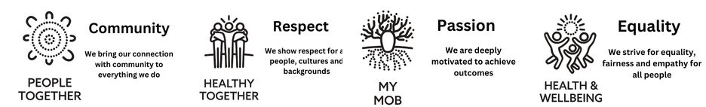

Position Title | ILCB Project Coordinator
Work Group | Social Supports Unit
Work Unit | Disability Services
Reports To | SEWB & Disability Services Manager
Direct Reports | 02
Award / Agreement | Social, Community, Home Care and Disability Services Industry Award  Aboriginal and Torres Strait Islander Health Workers and Practitioners and Aboriginal Community Controlled Health Services Award 2020 (Cth)
Award Classification | Grade 5 ($86,619.94 - $90,267.63)
Approved by CEO | 28.08.2023

Team Structure

CEO

SEWB & DSM

ILCB Project Coordinator

Disability Support Worker
Disability Support Worker

Position Purpose
This position is responsible for undertaking the development of key OVAHS initiatives related to community awareness raising, health promotion and self-advocacy, capacity building for aboriginal people living in the East Kimberley with a disability. The role works as part of the OVAHS team in providing a quality and person-centered health care, whilst ensuring the focus of care is on the needs of Aboriginal patients within the context of the persons cultural identity, family, and social circumstances.
Aboriginal and/or Torres Strait Islander persons are strongly encouraged to apply.
Strategic Alignment
The organisation’s Strategic Plan 2023- 2026 has four (4) overarching strategic goals, with each goal having specific outcomes.

The role of ILC Project Coordinator is aligned with all four Strategic Goals.
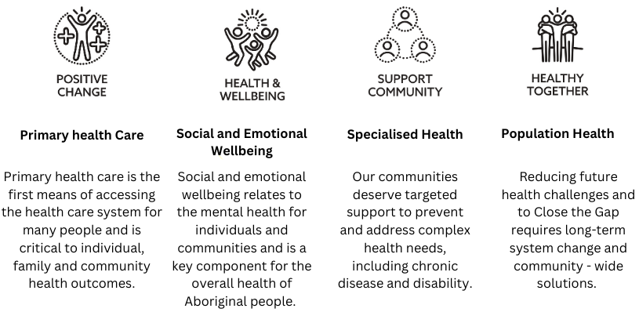
Key Stakeholder Relationships

External
- Aboriginal Community Controlled Health Services across the Kimberley region and Western Australia, other not-for-profit services, and businesses as relevant to the role
- Liaises with a variety of government agencies, stakeholder representative groups and community groups.
Internal
- Maintains close working relationships with other officers, team members and employees of Ord Valley Aboriginal Health Services.
- Works in collaboration with the Senior Management Team and in consultation with the Board of Directors.

Responsibilities of this Position
- Enhance access and engagement of Aboriginal Families living with a disability to improve health and wellbeing outcomes.
- Enhance access and engagement of Aboriginal families with children that have a developmental delay to culturally appropriate services.
- Consulting with key stakeholders and establishing an advisory group (which will comprise of people with disabilities) to develop culturally appropriate peer support/led health promotion and education programs.
- Work collaboratively with the OVAHS multi-disciplinary team members to determine service needs, activities and goals that identified Aboriginal communities aim to achieve and the coordination of outcomes.
- Provide education sessions and information sessions to families, Aboriginal communities and local community groups regarding disability, and the importance of providing opportunities for Aboriginal families with disabilities to access programs, activities and sporting groups to improve and maintain healthy lifestyle choices.
- Develop and deliver culturally secure education and training sessions at a local level to stakeholders and OVAHS staff.
- Regularly report on progress and financials to the Department of Social Services

Quality Management System
- Actively participate in the organisation’s QMS (LOGIQC).
- Identify and participate in continuous quality improvement activities and apply quality improvement principles to all duties performed.
Demonstrate leadership and commitment to promote continuous quality improvement initiatives, give assurance that the quality objectives are measured and ensure the QMS achieves intended results by engaging and supporting employees to contribute to the effectiveness of the QMS

General
- Demonstrate a strong commitment to uphold and contribute to the organisation’s mission, objectives, and values.
- Support and promote teamwork through open communication, collaboration and contribute to a positive workplace culture.
- Attend and participate in professional development activities including workshops and training as required.
- Attend and participate in Employee Development Days.
- Participate and comply with all Work Health and Safety responsibilities as per the Work Health and Safety Act 2020 (WA).
- Identify and assist in reducing Work Health and Safety hazards and risks.
Follow the reasonable direction of Work Health and Safety representatives.

Qualifications, Skills, Experience and Knowledge
Essential
- Qualification in Aboriginal Health Work, Community Development, Disability Services, Health Promotion, or related discipline
- Qualification or experience in the delivery of training or education sessions.
- Self-motivating and ability to show initiative in a flexible adaptable working environment. Organise own workload with minimal direction
- Experience in the development and coordination of culturally secure projects while meeting deadlines
- Experience in working with Aboriginal communities and demonstrated knowledge of social determinants of health.
- Demonstrated ability in facilitation of new and existing stakeholder meetings, building and maintaining partnerships and networks.
- Knowledge of barriers and challenges Aboriginal families and their carers experience living with a disability or developmental delay.
- Demonstrated ability and experience in data collection and regular report submission
- Competent in the use of computer software and input of information.
- Ability to travel throughout the entirety of the East Kimberley (inclusive of short stays away from home) is a requirement of the role.

Desirable
- Experience working in an Aboriginal Community Controlled Health Organisation or an Aboriginal or Torres Strait Islander Community Organisation
- Experience and knowledge of families living with a disability

Practical Requirements
- A current National Police Check (within the previous 3 months).
- A current Working with Children Check
- A current C class Western Australian driver’s license and willingness to drive is essential.
- Some work outside of normal hours of duty will be required.
- Depending on the nature of the region, some travel on light aircraft may be required.
- NDIS Worker Screening Check
Acknowledgment and Acceptance by Appointed Employee
I certify that I have read and understand the responsibilities assigned to this position.

Employee Name:
Signature:
Date:

