Job Description Form
Registered Nurse – Generalist & Outreach

Vision Statement
Aboriginal people in Kununurra and the North-East Kimberley are supported to live

prosperous lives that are strong, healthy, and culturally safe.

The Purpose that defines us
We bring clinical, cultural, and community expertise to deliver accessible and
holistic health and wellbeing care for people in the North-East Kimberley.

Aboriginal Community-led
We are connected and accountable to the communities we serve. We are governed by Aboriginal community leaders. We deliver services in culturally safe ways, bringing the best of medical and cultural expertise to achieve positive health outcomes. Working with and responding to Aboriginal communities is central to what we do.

Organisational Values
The Ord Valley Aboriginal Health Service has been providing critical health and support services to local Aboriginal people since 1984. Our ambition is to deliver socially, culturally, and financially accessible health care that supports communities in the North-East Kimberley to be strong, healthy, and safe. The organisation operates on the foundational pillars of Aboriginal leadership, self-determination and cultural diversity that underpin and shape the way the organisation conducts its business.

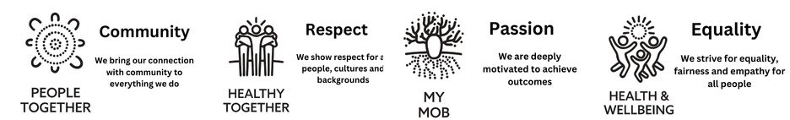

Position Title | Registered Nurse – Generalist and Outreach
Work Group | Clinic
Work Unit | Clinic  Outreach
Reports To | Practice Nurse Manager
Direct Reports | 0
Award / Agreement | Nurses Award 2020
Award Classification | Level 2 ($90,396.07 - $95,000)
Approved by CEO | 22.08.2023

Team Structure

Position Purpose

This role is responsible for providing primary health care (PHC) services to clients at the OVAHS clinic in addition to coordinating and attending community outreach clinics. OVAHS works from a holistic model of care with a focus on the needs of Aboriginal clients within the context of their cultural identity and social circumstances.

Aboriginal and/or Torres Strait Islander persons are strongly encouraged to apply.
Strategic Alignment
The organisation’s Strategic Plan 2023- 2026 has four (4) overarching strategic goals, with each goal having specific outcomes.

The role of Registered Nurse – Generalist and Outreach is aligned with all four Strategic Goals.
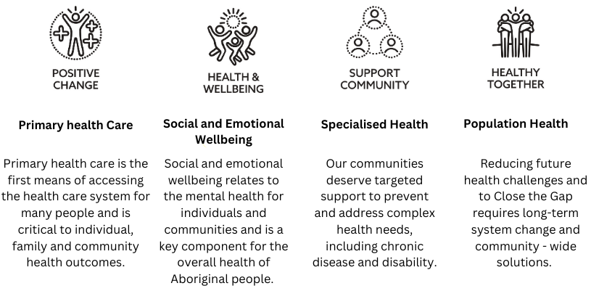
Key Stakeholder Relationships

External
- Aboriginal Community Controlled Health Services across the Kimberley region and Western Australia, other not-for-profit services, and businesses as relevant to the role
- Liaises with a variety of government agencies, stakeholder representative groups and community groups.
Internal
- Maintains close working relationships with other officers, team members and employees of Ord Valley Aboriginal Health Services.
- Works in collaboration with the Senior Management Team and in consultation with the Board of Directors.

Responsibilities of this Position

- Be accountable for the safe, efficient, and effective use of resources, including assisting with forward planning for OVAHS.
- Perform clinical duties, as part of the clinic team, in all areas of the health service, including general nursing care, emergency care and stabilisation, child health, chronic disease, antenatal, sexual health, and screening programs.
- Perform remote outreach services, with a member of the OVAHS clinical team, utilising endorsed clinical and organisational protocols and procedures.

NB. Community outreach clinics are only ever day trips and are subject to weather conditions.

- Follow best practice in clinical management of clients including recall, treatment, education, counselling and liaising with specialists and GP’s.
- Ensure coordinated patient care by: maintaining assessment and pathology schedules, referring to and working with allied health services, supporting patient self-direction in health care plans and preparing for visiting specialists clinics.
- Provide support, training, and education to OVAHS staff to increase knowledge and management of any area of expertise.
- Participate in completing the Medicare Benefits Schedule items including, but not limited to, 715; 721; 723 and 732.
- Provide education to clients in disease prevention, management of health conditions and treatment requirements.
- Participate in the development, presentation, evaluation and written reports of health programs and services.
- Promote OVAHS PHC services: Chronic Disease, Sexual Health, Maternal and Child Health, Women’s Health and the Social Support Unit services to clients and initiate referrals.
- Provide support and assistance to visiting Specialists, Allied Health Professionals, and other health agencies.
- Work with external agencies to deliver best practice client care including Community Health, Mental Health, Department of Child Protection, Environmental Health, Home and Community Care, Home Care Nurse and Hospital Services
- Maintain a clean and hygienic environment and participate in auditing, restocking, calibrating, and quality assurance and control activities.
Quality Management System
- Actively participate in the organisation’s QMS (LOGIQC).
- Identify and participate in continuous quality improvement activities and apply quality improvement principles to all duties performed.
- Demonstrate leadership and commitment to promote continuous quality improvement initiatives, give assurance that the quality objectives are measured and ensure the QMS achieves intended results by engaging and supporting employees to contribute to the effectiveness of the QMS.
General
- Demonstrate a strong commitment to uphold and contribute to the organisation’s mission, objectives, and values.
- Support and promote teamwork through open communication, collaboration and contribute to a positive workplace culture.
- Attend and participate in professional development activities including workshops and training as required.
- Attend and participate in Employee Development Days.
- Participate and comply with all Work Health and Safety responsibilities as per the Work Health and Safety Act 2020 (WA).
- Identify and assist to reduce Work Health and Safety hazards and risks.
- Follow the reasonable direction of Work Health and Safety representatives.

Position Performance Indicators
The below Key Performance Indicators (KPI’s) are used to assess, measure, evaluate, manage, and reward performance within each key result area of this position.

The below KPI’s are to be assessed in line with the organisation’s performance development framework.

Key Result Area | Key Performance Indicators
Compliance & Reporting | - Effective completion of all Work Unit contractual obligations including program delivery, funding reports, evaluations, and compliance requirements.
Quality  Management  System (QMS) | - Ensure all tasks assigned to this position are completed within a six (6) week period.  - Actively lead continuous quality improvement initiatives across the organisation and promote an environment of effective CQI practices.
Competency Profile for this Position
Competencies are the specific knowledge, skills and attributes needed to successfully undertake the role. The profile is used for recruitment, performance review, planning, and training and development activities.

Qualifications, Skills, Experience and Knowledge
Essential

- Current registration with the Australian Health Practitioners Regulatory Authority – (AHPRA) as a Registered Nurse with at least 1 years post graduate nursing experience.
- Practice within clinical standards and quality of care, which is effective, efficient and in accordance with best practice and agreed standards and policies.
- Demonstrate a level of knowledge congruent with the clinical management and support of clients with various condition and illnesses.
- Knowledge and understanding of the issues pertaining to the health of Aboriginal people in rural and remote areas.

- Demonstrated knowledge, competence and attitude required to provide PHC nursing within a patient centred and culturally appropriate approach to care.
- Ability to work collaboratively and effectively as a part of an internal and wider external team in the provision of care.
- Skill set applicable to providing health promotion and education about many aspects of the disease process and healthy lifestyles to community members.
- Proficient in obtaining optimum use of Medicare Benefits Schedule as part of the process of patient care.
- Written and computing skills of a level congruent with developing and evaluating detailed care plans and for preparing reports for management.
- Demonstrate incorporation of quality and risk management within practice.
- Can function as a team member and with the capacity to work without supervision.
- Can work for short periods under extreme weather conditions when on outreach and community visits.
- Highly developed interpersonal skills including negotiation and consultation skills and the ability to proactively establish and sustain effective stakeholder relationships.
- Substantial experience in the development, review and implementation of policies and strategies with a sound understanding of Aboriginal Community Controlled Health Services and processes.
- Demonstrated ability to uphold the principles of cultural safety including an ability to communicate effectively and sensitively with Aboriginal and Torres Strait Islander peoples.
Desirable
- The person identifies as Aboriginal and/or Torres Strait Islander and is acknowledged as such by their community.
- Previous experience working in a PHC setting.
- Postgraduate/certificate level in a relevant PHC area

Practical Requirements
- A current Western Australian driver’s license and willingness to drive is essential.
- A current National Police Check (within previous 3 months).
- A current Working with Children Check
- Some work out of normal hours of duty may be required.
- Depending on the nature of the region, some travel on light aircraft may be required.
- Intra and inter-state travel including overnight absences may also be required.

Acknowledgment and Acceptance by Appointed Employee
I certify that I have read and understand the responsibilities assigned to this position.

Employee Name:
Signature:
Date:

